Project Management Plan
2020-21 Local Government Levy Ready Grant Program (Round 2)
Applicants are to submit a Project Management Plan (PMP) with their application for funding under the 2020-2021 Local Government Levy Ready Grant Program. The figures provided in the PMP will be used by the Department of Local Government, Racing and Multicultural Affairs to review the progress of a project, as reported in Quarterly Progress and Final Project Reports.

Council details
Council name
Council contact
Position
Phone |  | Email

Project details
Project (title)
Project reference number
Project type | ☐ Upgrade waste disposal site so it meets impending legislative requirements.  ☐ Transition waste disposal site so it is no longer a levyable waste disposal site subject to section 59 of the Act.
Estimated Start Date (DD/MM/YYYY): |  | Estimated End Date (DD/MM/YYYY):

Project phases/schedule
Please detail below individual project activities in sequential order. Each activity must relate to an approved project component e.g. the closing and capping of the site’s landfill. If a Gantt chart has been prepared for this project, please attach.
Project task/activity | Scheduled start date | Scheduled completion date | Estimated Cost
E.g. planning, investigation and design | DD/MM/YYY | DD/MM/YYYY | $
*Add and delete rows as required.
Total Project Cost |  |  | $

Funding and subsidy forecasts
The Department will pay successful recipients grant funds in instalments. In order to be paid an instalment, the recipient must have expended all instalments previously paid.
Amount | Milestone
First Payment  60% of the approved subsidy | Upon approval of the project and execution of the Project Funding Schedule by both parties.
Second and Subsequent Payments  Up to 30% of the approved subsidy | Upon the department’s receipt of a satisfactory progress report and subsidy claim form.
Final Payment  10% of the approved subsidy | Upon the department’s receipt of a completed final project report and subsidy claim.
Please indicate below the dates by which you estimate the local government will have expended each instalment paid in conducting eligible project activities. The Claim amounts listed should mirror the forecast above, e.g. that 60 percent of funding be paid upon execution of the Project Funding Schedule.
Forecast # | Future Claim Date | Claim Amount
Forecast 1 | Date | $
Forecast 2 | Date | $
Forecast 3 | Date | $
Forecast Total |  | $

Risk Management Register
Risk Management Register
Please attach a Risk Management Register detailing all potential risks that may impact on the commencement and/or completion of your project. Please note, a template Risk Management Register is provided at Appendix A.
☐ A Risk Management Register has been completed and attached.

Communications
Provide a summary of any project-related media and communications both during the Funding Period. Add rows to tables if required.
Date (DD/MM/YYY) | Media/publications/events
*Add and delete rows as required

Declaration
I declare that all the information provided in this Project Management Plan is true and correct and no information is false or misleading.
I am authorised by my organisation to complete this form.
I agree that the Department of Local Government, Racing and Multicultural Affairs or the Department of Environment and Science does not accept any liability for the project.
☐ I agree with the above declaration

Name of authorised person
(Chief Executive Officer or formal delegate)
Position
Signature |  | Date

Please email/submit this form with your application for funding under the 2020-2021 Local Government Levy Ready Grant Program. Application forms and their attachments should be emailed to the Department of Local Government, Racing and Multicultural Affairs at 2020-21LocalGovernmentLevyReadyGrantProgram-Round2@dlgrma.qld.gov.au.

Appendix A – Risk Management Template
Provide details of any potential risks that may impact on the completion of this project.
# | Risk Category | Risk Description | Likelihood | Consequence | Rating | Mitigation/Treatment Strategy
*Add and delete rows as required

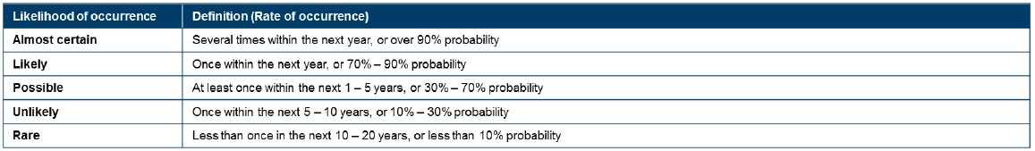
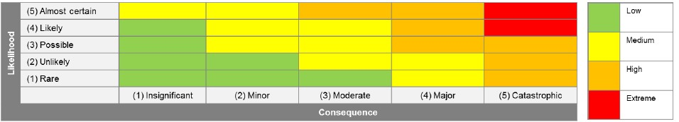
Legend:

